

**Linear Control Systems**

**(EE-379)**

**DE-42 Mechatronics**

**Syndicate –B**

**Report: Implementation of PID Control on Inverted Pendulum Using Simulink and Simscape**

**Names of Group Members as per CMS:**

1. NS Sarmad Ahmad Reg#
2. PC Sardar Abdullah khan Durani Reg #

Submitted to: LE Hamza Sohail

**Introduction:**

The inverted pendulum is a classic control system problem that involves balancing a pendulum in an inverted position on a moving platform. This system is inherently unstable and requires a control mechanism to maintain balance.

Simulink, a graphical programming environment, was employed to create a dynamic simulation of the inverted pendulum system. Simulink provides a visual representation of the system's behavior, making it an effective tool for control system design and analysis.

Simscape, a physical modeling tool, was chosen to create a more detailed and physically accurate representation of the inverted pendulum system. Simscape allows for the modeling of multidomain physical systems, enabling a more realistic simulation.

The Proportional-Integral-Derivative (PID) control algorithm was implemented in both the Simulink and Simscape models to stabilize the inverted pendulum. PID control involves adjusting three parameters—proportional, integral, and derivative—to achieve a balance between system stability and responsiveness.

**Calculations:**

System Equations for Inverted Pendulum:

The dynamic equations governing the inverted pendulum system were derived based on the principles of physics and mechanics. These equations describe the relationship between the position, velocity, and acceleration of the pendulum.

The PID controller parameters were determined through a trial-and-error process, involving adjusting each parameter iteratively. The goal was to find a set of PID parameters that would maintain the stability of the inverted pendulum system.

After rigorous testing the Simulink/Simscape model seemed to be the most stable at PID values:

P=100, I=1, D=20

**Block Diagrams:**

Simulink Model Block Diagram

Figure 1

The Simulink block diagram illustrates the interconnected components of the inverted pendulum model, including sensors, actuators, and the PID controller.

Simscape Model Block Diagram

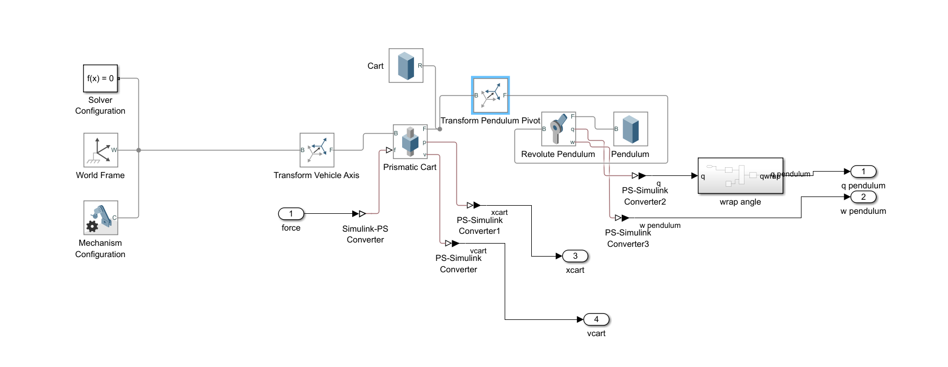

Figure 2

The Simscape block diagram provides a detailed representation of the physical components of the inverted pendulum system, including mechanical and electrical elements.

**Results:**

Simulink Model Results

Simulation results from the Simulink model indicated initial challenges in maintaining stable balance.

The PID controller demonstrated effectiveness but required further calibration for optimal performance. Challenges encountered during PID calibration in the Simulink model included overshooting and oscillations. Fine-tuning of PID parameters was necessary to address these issues and achieve a more stable response.

Figure 3

Simscape Model Results

Simulation results from the Simscape model demonstrated improved stability compared to the Simulink model. The PID controller in the Simscape model exhibited better calibration, leading to smoother and more controlled pendulum motion.

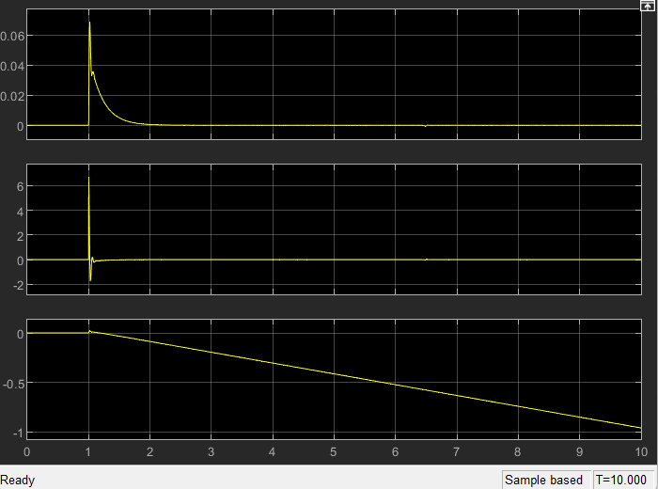

Figure 4

Comparison of Results

The Simscape model outperformed the Simulink model in terms of stability and PID calibration. Comparative analysis highlighted the advantages of using a more detailed physical model for system simulation.

**Conclusion:**

The implementation of PID control in both Simulink and Simscape models showed promising results in stabilizing the inverted pendulum system. The Simscape model's success suggests the importance of detailed physical modeling for accurate system representation. In conclusion, the study successfully demonstrated the application of PID control in stabilizing an inverted pendulum system. Further improvements and exploration of advanced modeling techniques could enhance the performance of such control systems in practical applications.